**Name: saline k.b**

**Roll No:33**

**Batch:mca-B**

**Date:24-3-2022**

**NETWORKING & SYSTEM ADMINISTRATION LAB**

**Experiment No.: 3**

**Aim**

Familiarization with various linux commands.

**Procedure**

**1]pwd**

**Description:Display present working directory.**

**Command:$ pwd**

**Output Screenshot**

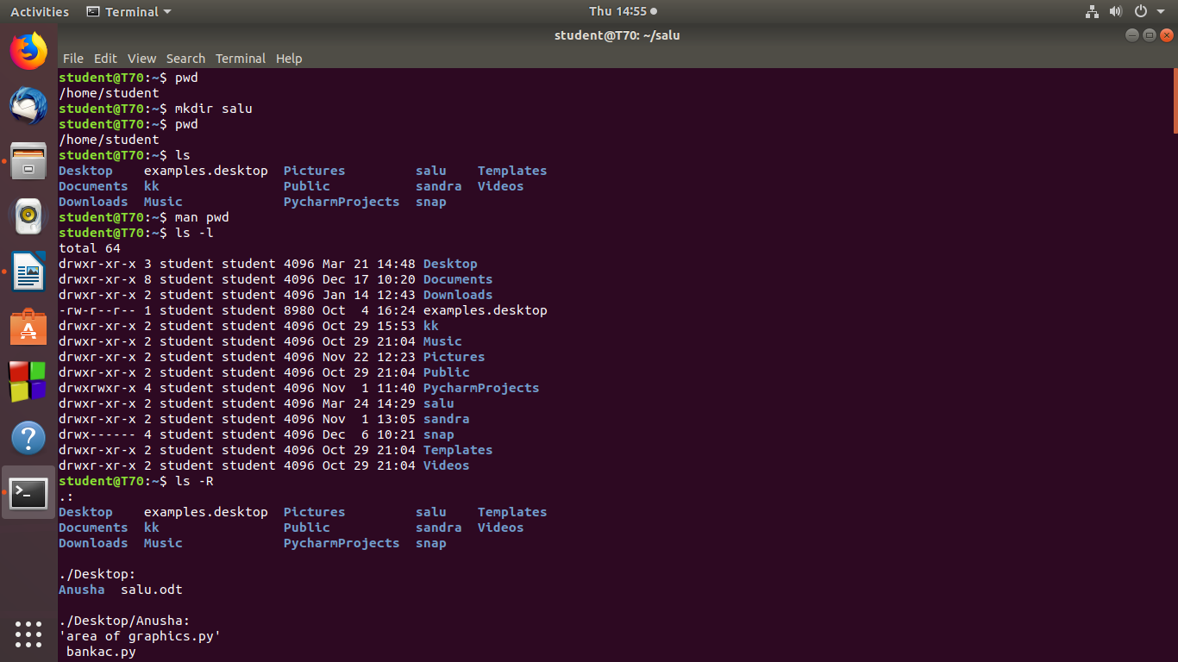

**2]mkdir**

**Description:Create new working directory.**

**Output Screenshot**



**3]ls**

**Description:List the Directory file subdirectory etc…**

**Output Screenshot**



**3.1]ls -l**

**Description:Longlisting Additional informations.**

**Output Screenshot**



**3.2]ls -R**

**Description:Description subdirectory informations.**

**Output Screenshot**



**3.3]ls -a**

**Description:Shows hidden files starting with dots.**

**Output Screenshot**

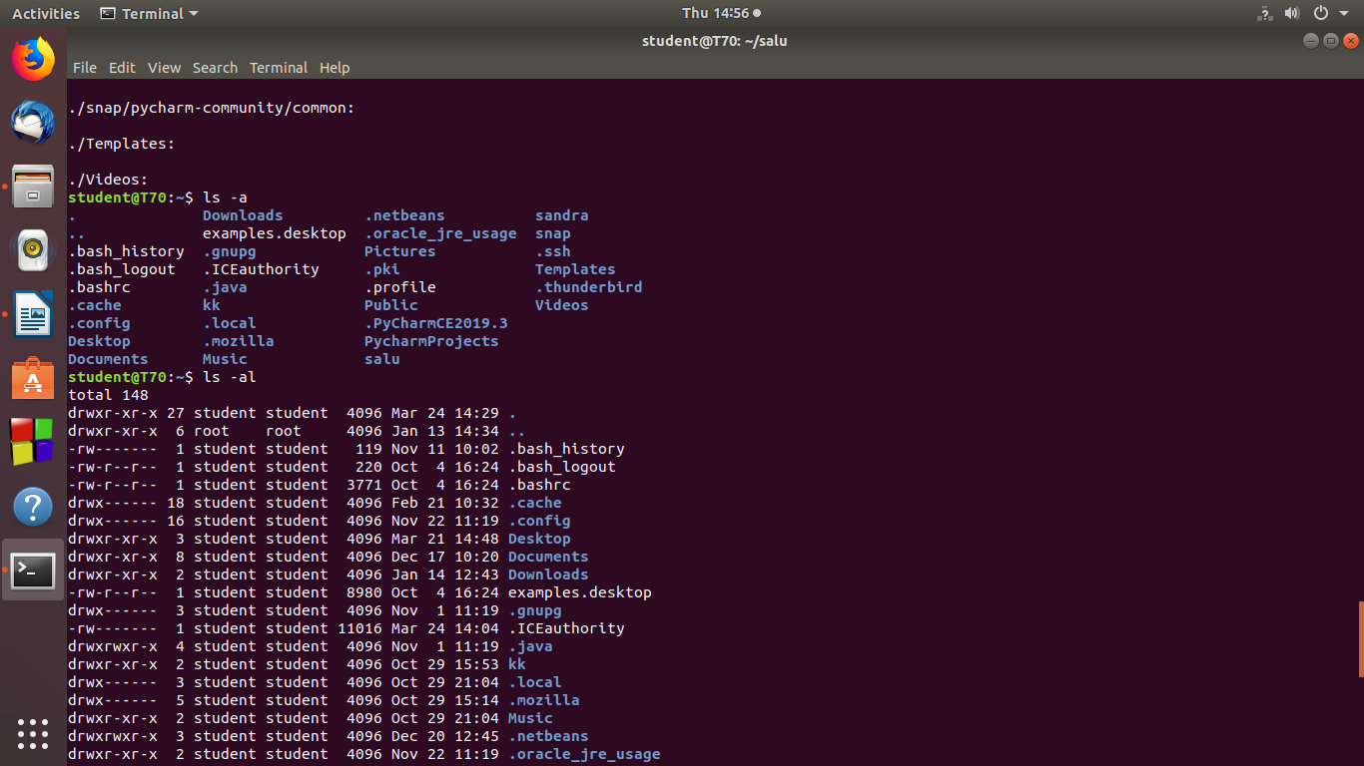

**3.4]ls -al**

**Description:List all files and directories with permissions.**

**Output Screenshot**



**3.5]ls -t**

**Description:Display informations with last modified order.**

**Output Screenshot**

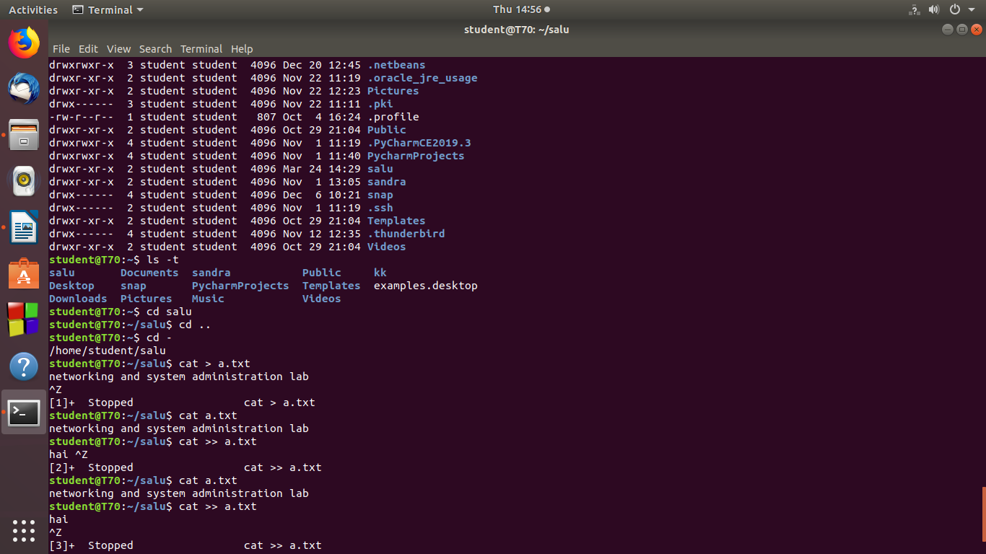

**4]cd[change directory]**

**4.1]cd salu**

**Description:Move to current directory.**

**Output Screenshot**



**4.2]cd ..**

**Description:Move to previous directory.**

**Output Screenshot**



**4.3]cd -**

**Description:Back to current directory.**

**Output Screenshot**



**5]cat [To create new file]**

**5.1]cat > filename**

**Description:To create new file.**

**Output Screenshot**



**5.2] cat filename.txt**

**Description:To view the content of the file**

**Output Screenshot**



**5.3] cat >> filename.txt**

**Description:Inoder to add more contents.**

**Output Screenshot**



**5.4] cat filename.txt > newfilename.txt**

**Description:To copy the content of one file to another file.**

**Output Screenshot**

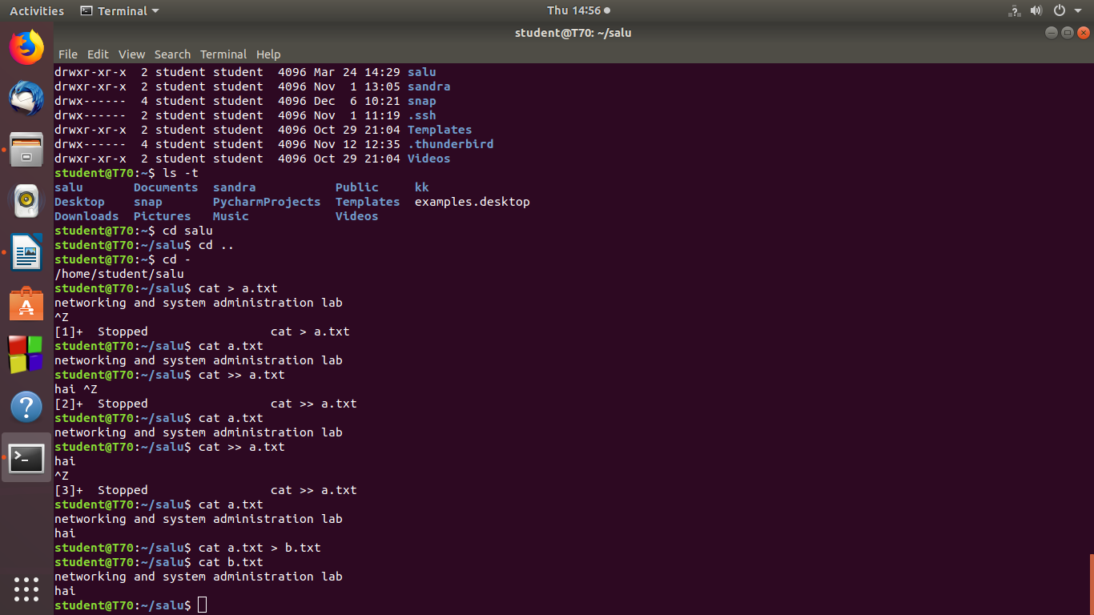

**5.5 ] cat newfilename.txt**

**Description:To view the content in new file.**

**Output Screenshot**

